Ahorn | 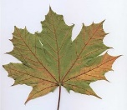 | Linde | 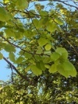
Birke | 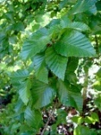 | Kastanie | 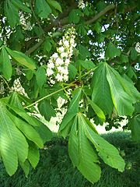
Buche | 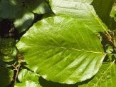 | Pflaume | 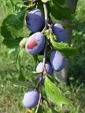
Gingko | 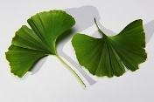 | Walnuss | 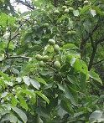
Eiche | 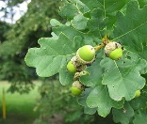 | Birne | 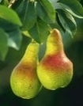

Memory Laubbäume
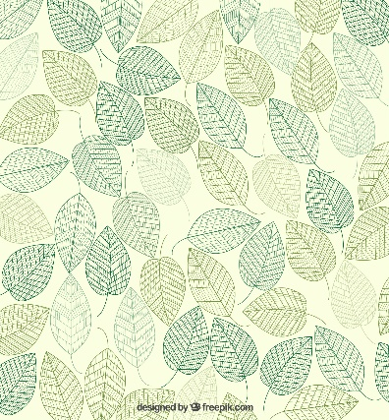

Memory Laubbäume Rückseiten

Bildlizenzen
Ahorn: von Thomas Netsch, Wikipedia project, public domain
Buche: By Willow (Own work) [GFDL (http://www.gnu.org/copyleft/fdl.html), CC BY-SA 3.0 (http://creativecommons.org/licenses/by-sa/3.0) or CC BY 2.5 (http://creativecommons.org/licenses/by/2.5)], via Wikimedia Commons
Eiche: By Maufi at the German language Wikipedia [GFDL (http://www.gnu.org/copyleft/fdl.html) or CC-BY-SA-3.0 (http://creativecommons.org/licenses/by-sa/3.0/)], via Wikimedia Commons
Birke: By Philippe Giabbanelli (Own work) [CC BY 3.0 (http://creativecommons.org/licenses/by/3.0)], via Wikimedia Commons
Gingko By THOR (originally posted to Flickr as Gingko Leaf) [CC BY 2.0 (http://creativecommons.org/licenses/by/2.0)], via Wikimedia Commons
Linde: von JoJan, GNU Lizenz, Wikimedia
Kastanie: von Nikanos (Eigenes Werk) [CC BY-SA 2.5 (http://creativecommons.org/licenses/by-sa/2.5)], via Wikimedia Commons
Pflaume: von Cherubino (Eigenes Werk) [CC BY-SA 3.0 (http://creativecommons.org/licenses/by-sa/3.0)], via Wikimedia Commons
Birne: von Keith Weller (USDA, Image Number K5299-1.) [Public domain], via Wikimedia Commons
Walnuss: von Rasbak, GNU Lizenz, Wikimedia

Design Rückseite:
Freepic.com / http://www.freepik.com (Designed by Freepik)

